PROFILE
V.Venkata ramana 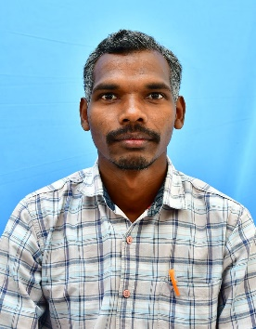

S/o Matsya raju
Baddimetta Village
Chintapalli Mandal
Alluri Sitharama raju Dist Email: vvramana1451990@gmail.com
Andhra Pradesh- 531106 Mobile: 8332942811

Present Position: Lecturer in Mathematics, Govt. Degree College,
Chintapalli, Alluri sitha ramaraju Dist
.
Personal Details:

Name : V Venkata ramana
Father’s Name : V Matsya raju(Late)
Mother’s Name : V Kondamma
Date of Birth : 14-05-1990
Gender : Male
Marital Status : Married
Nationality : Indian
Languages Known: Telugu, English

Educational Qualifications:
Sl.No | Qualification | Institution | Academic Year | Year of Passing | Percentage
1 | M.Sc | Andhra University  Visakhapatnam | 2015-17 | 2017 | 65.2%
2 | B. Ed | Andhra University  Visakhapatnam | 2015-15 | 2027 | 82%
5 | B.Sc. | Govt Degree College,Chintapalli | 2010-13 | 2013 | 66.3%
6 | Intermediate | Board of Intermediate Education, AP | 2008-10 | 2010 | 65.7%
7 | SSC | Board of Secondary Education, AP | 2007-08 | 2008 | 76.3%

